🟢 Bandit Level 11 → Level 12
The password is in data.txt, but all uppercase and lowercase letters have been rotated by 13 positions — this is called ROT13.
Step 1: Check the file
ls
You should see:
data.txt
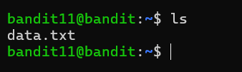
Step 2: Decode ROT13
Use:
cat data.txt | tr 'A-Za-z' 'N-ZA-Mn-za-m' to get the password
The password for the next level is stored in the file data.txt, where all lowercase (a-z) and uppercase (A-Z) letters have been rotated by 13 positions so we use that comment to retrieve the password
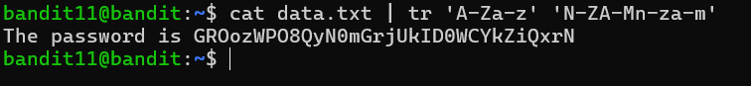
🔑 The output is the password for bandit12.
Then exit from that level

